* **List (in java):** In java, a list is an ordered collection of objects in which duplicate values can be stored. Since a list preserves the insertion order, it allows positional access and insertion of elements. List is implemented by the following classes:
* [Arraylist](https://www.educative.io/edpresso/what-is-an-arraylist-in-java) {currently implementing list with this}
* Linkedlist
* Vector
* Stack
* **Arraylist (in java):** The arraylist class is a resizable [array](https://www.w3schools.com/java/java_arrays.asp). The difference between a built-in array and an arraylist in java, is that the size of an array cannot be modified (if you want to add or remove elements to/from an array, you have to create a new one). While elements can be added and removed from an arraylist whenever you want.
* **Creating list objects (in java):** The instances / objects or declaration of arraylist of a list can be created in the following ways:
* listType is the class that is implementing the list.
* objType is the data type of the values in the list.
* listName is the name of the list.

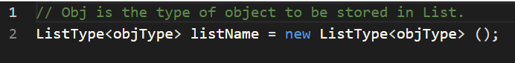

(Implementation)

